Distributed Architecture: Distributed Component Architecture. The leading vehicles communicate with at most three vehicles behind.

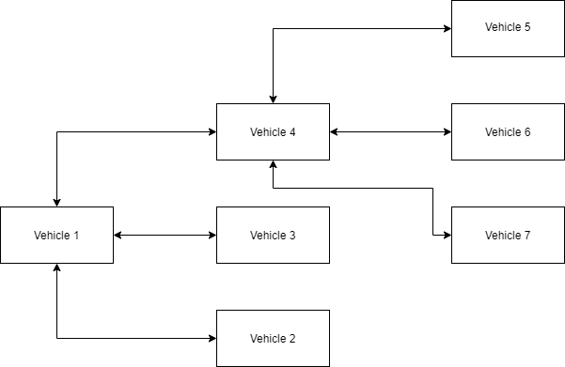

The length of a truck in Germany is between 18 and 25 meters. The following distance between two trucks should be equivalent to the distance travelled by the vehicle in 4 seconds [1]. The maximum speed of trucks is 80 km/h. So, the recommended distance between two trucks is about 90 meters. For a convoy of three, the total distance between the leading truck and the last truck is 205 m. If the convoy de-couples to allow another vehicle in, the distance between the trucks is increased by 205 m. I a convoy of 4 with each vehicle decoupled, the total distance is 665 m

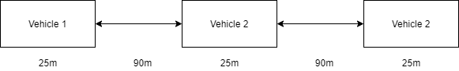

Parallel Architecture: The memory architecture for each multicore processor in each vehicle is a distributed memory architecture. Increases redundancy due to the high risk of the task at hand. The different functions of a vehicle have a processor assigned to that function.

Scalability. The number of vehicles in the convoy should be able to vary between 2 and 20

Latency. The latency of the communication between the vehicle in the front of the convoy and the last vehicle in the convoy should be low to reduce the possibility of accidents.

Synchronized Clock: The clocks in each vehicle are synchronized using GPS by Simple Network Time Protocol.

For the network the requirements are high bandwidth, low latency, long range, fault tolerance and deterministic characteristics. The network chosen is Dedicated short-range communications. The range is 300 m.

Programming each processor using OpenMP for multithreading and CUDA.

The hardware chosen is the Nvidia Drive PX2 computer.

[1] https://www.cedr.eu/download/Publications/2010/e_Distance_between_vehicles.pdf